Mrs. Moore’s Newsletter
September

August 6th -10th

v
Sight Words

red, blue, yellow, green, orange
purple, brown, black
an, can, not

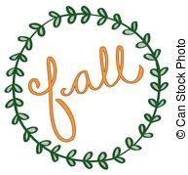

Dates to Remember
- September 7th-10th Color Days
- September 10th -Scholastic Book order forms due
- September 14-21st Fall Book Fair

Notes from the teacher:
- Here are the color days
Friday Sept 3rd- Orange
Tuesday September 7th-Purple
Wednesday September 8th- Brown
Thursday September 9th- Black
Friday September 10th- Rainbow
- Please notify the school nurse if your child has been in contact with a COVID positive individual or has tested positive

Happy Birthday!
Bennett 09/02
Grady 09/19

Reading | Writing | Misc | Math
- Introducing Oo, Cc, Ss,Uu, Qq, Jj, Ll,Gg, Hh, Kk, Zz, Ww, Yy, Xx  - Sight Words | - Daily journals | - Color words  - Chicka Chicka Boom Boom | - Continue with 0-5  - Topic 1 assessment  - Comparing Numbers to 5

Contact information: mmoore@sputnam.k12.in.us

